AI Hardware Investment Research

Investment Thesis
We are in the early innings of AI inference demand. Even if frontier model training stopped today, current models are capable enough to fuel years of enterprise implementation and increased usage. Coding assistants already generate constant inference, and voice agents and autonomous workflows will only expand this further. The probability that inference growth slows meaningfully appears low.
This cycle is worth playing. We may be 12 months late, but the opportunity is multi-year. One approach is to invest at the hardware layer.
Why hardware? AI inference is built directly on a defined set of physical components. If we identify the right enablers of inference, we can participate in this cycle regardless of which model or inference implementation wins. This differs from the cloud era, where x86 hardware was commoditised because the bottleneck was software implementation, not compute.
The economic opportunity is substantial. AI inference attacks large budgets. Cloud apps addressed on-prem infrastructure with TCO advantages; AI addresses headcount budgets with even stronger relative TCO. A 10x ROI on a $120k FTE implies $12k ACV per role replaced. As scope expands, we could see far higher ACVs with strong willingness to pay.
Why current architectures create bottlenecks. LLMs process tokens sequentially, which fundamentally rebalances computing requirements. Components that were once minor are now critical. Memory bandwidth, interconnect speed, and packaging density face excessive demand relative to the old cloud paradigm.
Why look beyond Nvidia? First, lesser-known players may offer greater returns. Second, customers will continue diversifying away from Nvidia to improve purchasing power. There are opportunities in companies that succeed regardless of who provides the compute nodes.

Core Assumptions
- We're in early innings for inference demand
- Current infrastructure cannot satisfy demand
- Willingness to pay for inference will continue to increase
- Context and memory become more important (persistent state vs. zero-shot RAG per call)

How Inference is Evolving
AI inference is becoming more continuous and higher skill. Context windows and persistent state become more important as use cases mature.
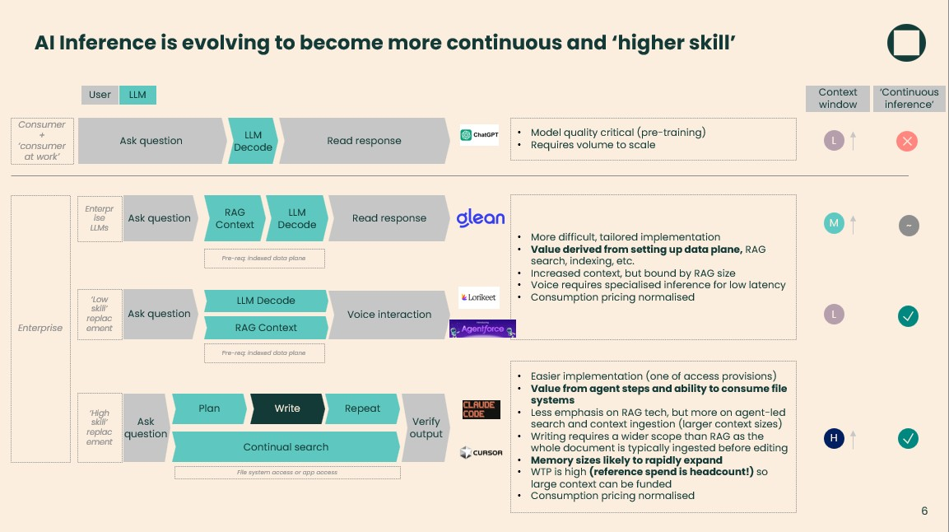

The Equipment Landscape
Chips move through four stages: Design → Front End (Wafer Fab) → Middle (Packaging) → Back End (OSAT). Our focus is primarily on Middle and Back End—advanced packaging and inspection/test—where complexity is increasing fastest.
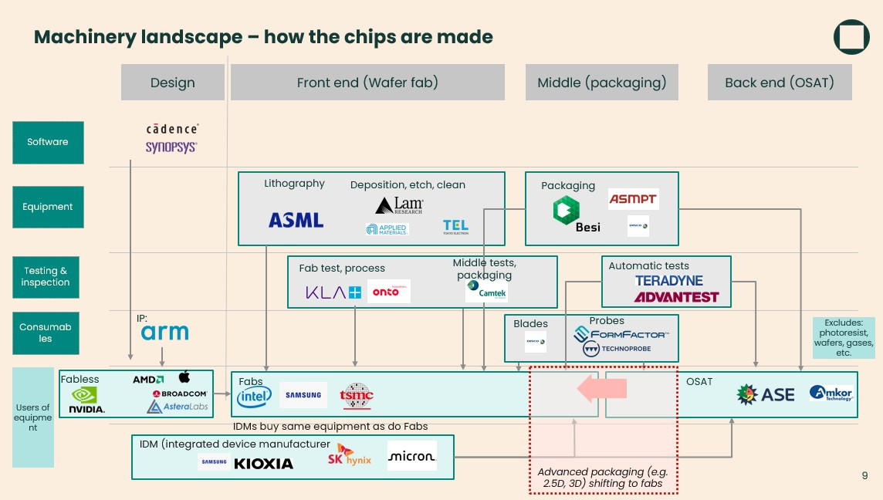
Priority Companies
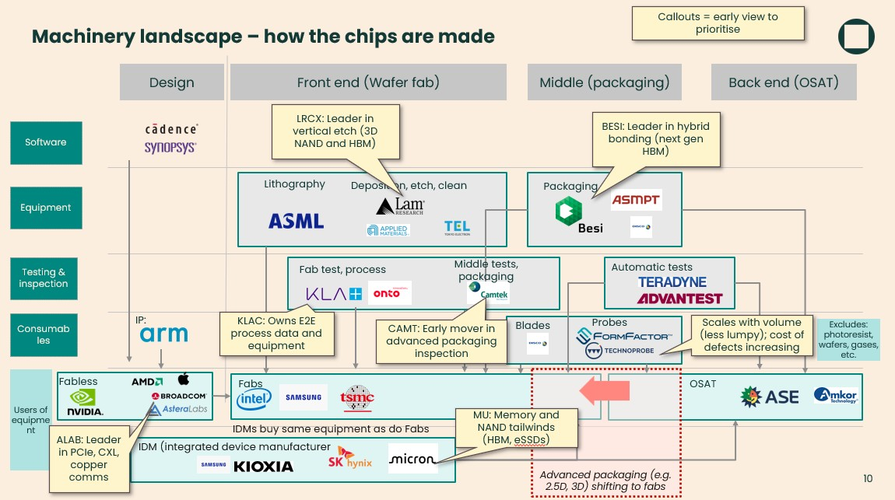

Priority Research
Memory
The memory wall is the primary bottleneck. KV caches for inference require HBM bandwidth that current supply cannot meet.
Company | Thesis Alignment | Founder-Led
Micron  (MU) | US-based memory IDM; one of three HBM suppliers (with SK Hynix, Samsung); sold out through 2026; direct beneficiary of KV cache demand | No (but CEO cofounded SanDisk)
Fabless Components
As bandwidth requirements increase, signal integrity over copper becomes harder. Leading edge retimers and switches become no-regrets purchases.
Company | Thesis Alignment | Founder-  Led
Astera Labs  (ALAB) | Leads high-frequency retimers and PCIe switches; wins regardless of which GPUs ship;  COSMOS software adds diagnostics moat | Yes
Equipment
Advanced packaging (HBM stacking, chiplets) requires new manufacturing processes. Equipment providers benefit from tech transitions.
Company | Thesis Alignment | Founder-  Led
BE Semiconductor  (BESI) | Near-monopoly in hybrid bonding; if HBM4 height limits require hybrid bonding,  BESI is the bottleneck | Yes
Lam Research (LRCX) | Etch/deposition leader; benefits from node transitions and new fab builds for AI capacity | No
Inspection & Test
Advanced packaging has lower yields. Every defect in a $40k GPU matters. Inspection scales with complexity and intolerance for defects.
Company | Thesis Alignment | Founder-  Led
Camtek (CAMT) | Back-end inspection for advanced packaging; benefits from CoWoS and HBM expansion | Yes (Israeli)
KLA (KLAC) | Process control leader; "MRI for chips"; scales with yield management needs at advanced nodes | No
FormFactor  (FORM) | Probe cards are consumables for chip testing; recurring revenue tied to test volume | No
Technoprobe  (TPRO) | Probe card competitor; benefits from same dynamics as FormFactor | Family-led
Storage
If context windows and model weights grow, fast storage for spillover and checkpointing becomes more critical.
Company | Thesis Alignment | Founder-Led
Pure Storage  (PSTG) | Flash storage for AI data pipelines; benefits from data gravity as AI generates more data | Founder is Chief Visionary  Officer

Product type comparison
Vendor | Ticker | Component | Est. Price | Purchasing Dynamic | Spend Type
Astera Labs | ALAB | Retimer Chip | $40-$75 | 1-to-Many: scales linearly with GPU shipments | Volume
FormFactor | FORM | Probe Card | $75k-$150k | Consumable: wears out from testing volume | Consumable
Technoprobe | TPRO | Probe Card | $50k-$100k | Consumable: same as FormFactor | Consumable
Pure Storage | PSTG | FlashBlade | $155k+ | Data Gravity: bought as data buckets fill | Capex
Camtek | CAMT | Inspection  System | $800k-$1M | Back-End Capacity: packaging line expansion | Capex
Vendor | Ticker | Component | Est. Price | Purchasing Dynamic | Spend Type
BE  Semiconductor | BESI | Hybrid Bonder | $2M+ | Tech Transition: enables HBM4/chiplets | Capex
Lam Research | LRCX | Etch/Deposition | $3M-$5M | Node Transition: new fabs and smaller nodes | Capex
KLA | KLAC | Plasma Inspector | $5M-$10M+ | Yield Management: defect intolerance | Capex
Micron | MU | HBM Stack | $300-$400 | Memory Demand: KV cache requirements | Volume

Founder-Led Reference
Public - Founder as CEO:
Astera Labs (ALAB) - Jitendra Mohan
BE Semiconductor (BESI) - Richard Blickman (since 1995) Camtek (CAMT) - Rafi Amit (co-founder, prev. CTO) Public - Founder Involved:
Pure Storage (PSTG) - John Colgrove (Chief Visionary Officer)
Technoprobe (TPRO) - Family-led (founder's nephew is CEO)
Other Notable Founder-Led in AI Hardware:
NVIDIA (NVDA) - Jensen Huang
Super Micro (SMCI) - Charles Liang
Monolithic Power (MPWR) - Michael Hsing
Dell (DELL) - Michael Dell
Broadcom (AVGO) - Henry Samueli (Chairman/CTO)
Arista (ANET) - Andy Bechtolsheim (Chairman/Chief Architect)

Other Companies in the AI Hardware Universe
Memory
Company | Ticker | Notes
SK Hynix | 000660.KS | HBM leader; ahead of Micron on HBM3E
Samsung | 005930.KS | Investing heavily for HBM4; catching up
Kioxia | Private | NAND flash; former Toshiba Memory
Solidigm | Private | NAND (SK Hynix / Intel JV)
Rambus | RMBS | Memory interface IP and security
Compute / Logic
Company | Ticker | Notes
NVIDIA | NVDA | Dominant GPU provider; Founder-led
AMD | AMD | GPU alternative; MI300 competing for AI
Intel | INTC | Gaudi accelerators; foundry ambitions
Broadcom | AVGO | Custom ASICs for hyperscalers; networking
Marvell | MRVL | Custom silicon; data infrastructure
Qualcomm | QCOM | Edge AI; mobile inference
Cerebras | Private | Wafer-scale AI chips; Founder-led
Groq | Private | LPU inference chips; Founder-led
Google (TPU) | GOOGL | In-house AI accelerators
Foundry
Company | Ticker | Notes
TSMC | TSM | Advanced packaging (CoWoS); node leadership
Equipment
Company | Ticker | Notes
ASML | ASML | EUV lithography monopoly
Applied Materials | AMAT | Deposition, etch, CMP
Advantest | 6857.T | Test equipment; duopoly with Teradyne
Teradyne | TER | Test equipment for semiconductors
EDA / Design Software
Company | Ticker | Notes
Synopsys | SNPS | Chip design software; Founder involved
Cadence | CDNS | Chip design and verification
Siemens EDA | SIEGY | Mentor Graphics acquisition
Interconnect / Networking
Company | Ticker | Notes
Arista Networks | ANET | Data centre switches; Founder involved
Cisco | CSCO | Networking infrastructure
Ciena | CIEN | Optical networking
Amphenol | APH | Connectors and cables
Company | Ticker | Notes
TE Connectivity | TEL | Connectors for high-speed data
Coherent | COHR | Optical components; transceivers
Lumentum | LITE | Optical components
Innolight | 300502.SZ | Optical transceivers (China)
Fabrinet | FN | Optical manufacturing; Founder involved
Credo Technology | CRDO | High-speed connectivity IP
Alphawave Semi | AWE.L | Connectivity IP; Founder-led
Components / Power
Company | Ticker | Notes
Monolithic Power | MPWR | Power management ICs; Founder-led
Vicor | VICR | Power modules for AI servers; Founder-led
Infineon | IFNNY | Power semiconductors
Microchip Technology | MCHP | MCUs, analog, FPGA
Lattice Semiconductor | LSCC | Low-power FPGAs
Silicon Motion | SIMO | SSD controllers; Founder-led
Phison Electronics | 8299.TW | SSD controllers; Founder-led
Montage Technology | 688008.SS | Memory interface chips; Founder-led
Storage
Company | Ticker | Notes
NetApp | NTAP | Enterprise storage
VAST Data | Private | AI-native storage; Founder-led
WEKA | Private | High-performance file system; Founder-led
DDN | Private | HPC and AI storage; Founder-led
Systems / Servers
Company | Ticker | Notes
Dell Technologies | DELL | AI servers; Founder-led
HPE | HPE | AI infrastructure
Super Micro | SMCI | GPU server specialist; Founder-led
Power / Cooling Infrastructure
Company | Ticker | Notes
Vertiv | VRT | Data centre power and cooling
Eaton | ETN | Power management
Schneider Electric | SBGSY | Data centre infrastructure
CoolIT Systems | Private | Liquid cooling for data centres

Template
See Templates/Company Template for the standard analysis framework.

